8/19 (11:30-2pm) | Safeguarding God’s Children
9/3 | Labor Day - No Sunday School
9/10 | Parish Family Retreat
9/17 | Ice Cream Social  Deadline for Sunday School Registration
9/24, 10/1, 10/8, 10/15 | Workshop #1: What Makes My Church Special
10/15 | Sing Offertory with the ECA Choir – 10:30 Service
10/22 | Workshop #2: The Moses Chronicles, Week 1
10/29 | Pancake Breakfast
11/5, 11/12, 11/19 | Workshop #2:The Moses Chronicles, Weeks 2 - 4
11/19 | Sing Offertory with the ECA Choir – 10:30 Service
11/26 | Advent Wreath Making
12/3, 12/10, 12/17 | Christmas Pageant Rehearsal
12/24 (5:00 pm) | Christmas Eve Service w/Children’s Pageant
12/31 | No Sunday School
1/7, 1/14, 1/21, 1/28 | Workshop #3: Let there Be Light
1/28 | Sing Offertory with the ECA Choir – 10:30 Service
2/4, 2/11, 2/18, 2/25 | Workshop #4: 12 Who Changed the World
2/25 | Sing Offertory with the ECA Choir – 10:30 Service
3/4, 3/11, 3/18, 3/25 | Workshop #5: This is My Body
3/25 | Sing Offertory with the ECA Choir – 10:30 Service
4/1 | No Sunday School
4/8 | Egg Hunt
4/15, 4/22 | Workshop #6: 100 Ways to Pray, Weeks 1 & 2
4/29 | Pancake Breakfast
5/6, 5/13 | Workshop #6: 100 Ways to Pray, Weeks 3 & 4
5/13 | Sing Offertory with the ECA Choir – 10:30 Service
5/20 | Teacher Appreciation Sunday

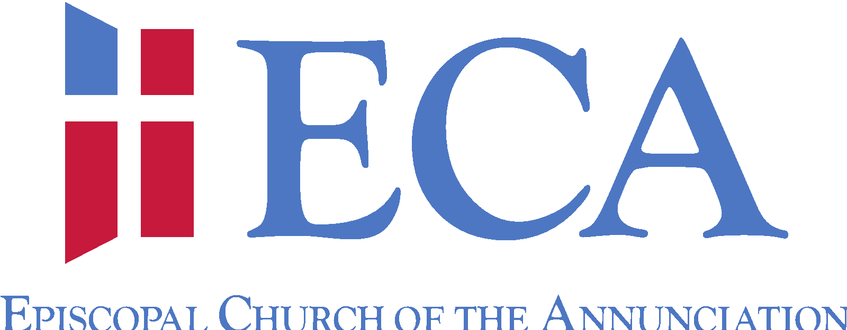

Children’s Christian Education Calendar
2017-2018

“Our Mission is to bear witness to God’s love and invite, encourage,
and prepare God’s people to share that grace with others.”

Workshop #1:
What Makes My Church Special?

In this unit, children will learn that they are an important part of ECA. Lessons will focus on our worship space, church campus, and liturgy, helping our children to feel more connected and involved in worship and parish events.

 | Week 1  9/24 | Week 2  10/1 | Week 3  10/8 | Week 4  10/15
3-4 year olds | Music: Singing with the ECA Choir | Kitchen: Making Communion Bread | Drama: Scavenger Hunt | Art: Stained Glass Windows
Kindergarten –  1st graders | Art: Stained Glass Windows | Music: Singing with the ECA Choir | Kitchen: Making Communion Bread | Drama: Scavenger Hunt
2nd-3rd graders | Drama: Scavenger Hunt | Art: Stained Glass Windows | Music: Singing with the ECA Choir | Kitchen: Making Communion Bread
4th-5th  graders | Kitchen: Making Communion Bread | Drama: Scavenger Hunt | Art: Stained Glass Windows | Music: Singing with the ECA Choir
** Children 3 yrs – 5th Grade will sing the Offertory
with the ECA Choir at the 10:30 Service on 10/15. **

Workshop #2:
The Moses Chronicles

Moses is one of the most well known characters in the Old Testament, and his story provides a rich background from which to learn. This cycle is filled with information and activities covering much of Moses’ life. This cycles offers an opportunity to learn about our Jewish roots, helping children to understand the Eucharist in a whole new way.

 | Week 1  10/22 | Week 2  11/5 | Week 3  11/12 | Week 4  11/19
3-4 year olds | Music: Scarf Skits and Games | Kitchen: Eating a Passover Meal | Drama: The Story of the Ten Plagues | Art: 10 Commandment Tablets with Tiles
Kindergarten –  1st graders | Art: 10 Commandment Tablets with Tiles | Music: Scarf Skits and Games | Kitchen: Eating a Passover Meal | Drama: The Story of the Ten Plagues
2nd-3rd graders | Drama: The Story of the Ten Plagues | Art: 10 Commandment Tablets with Tiles | Music: Scarf Skits and Games | Kitchen: Eating a Passover Meal
4th-5th  graders | Kitchen: Eating a Passover Meal | Drama: The Story of the Ten Plagues | Art: 10 Commandment Tablets with Tiles | Music: Scarf Skits and Games
** Children 3 yrs – 5th Grade will sing the Offertory
with the ECA Choir at the 10:30 Service on 11/19. **

Workshop #3:
Let There Be Light

During this unit, children will study the story of Creation. Children will learn about the days of creation and what was created on each day. Ultimately, children will understand that God is the source of all life, and that we are called to be good stewards of His Creation.

 | Week 1  1/7 | Week 2  1/14 | Week 3  1/21 | Week 4  1/28
3-4 year olds | Music: Creation Songs | Kitchen: Story of Creation Trail Mix | Garden: Planting Paperwhites | Art: Paining Recycling Cans
Kindergarten –  1st graders | Art: Paining Recycling Cans | Music: Creation Songs | Kitchen: Story of Creation Trail Mix | Garden: Planting Paperwhites
2nd-3rd graders | Garden: Planting Paperwhites | Art: Paining Recycling Cans | Music: Creation Songs | Kitchen: Story of Creation Trail Mix
4th-5th  graders | Kitchen: Story of Creation Trail Mix | Garden: Planting Paperwhites | Art: Paining Recycling Cans | Music: Creation Songs
** Children 3 yrs – 5th Grade will sing the Offertory
with the ECA Choir at the 10:30 Service on 1/28. **

Workshop #4:
12 Who Changed the World

In this unit children will learn about the twelve men who helped him do God’s work. These twelve disciples (which means student) were ordinary people who helped do extraordinary things. Children will explore what it means to follow Jesus and that Jesus calls us to do God’s work too.

 | Week 1  2/4 | Week 2  2/11 | Week 3  2/18 | Week 4  2/25
3-4 year olds | Music: Learning the Disciples Song | Kitchen: Making Fish Cookies | Drama: Stories about the Disciples | Art: Making Ichthys
Kindergarten –  1st graders | Art: Making Ichthys | Music: Learning the Disciples Song | Kitchen: Making Fish Cookies | Drama: Stories about the Disciples
2nd-3rd graders | Drama: Stories about the Disciples | Art: Making Ichthys | Music: Learning the Disciples Song | Kitchen: Making Fish Cookies
4th-5th  graders | Kitchen: Making Fish Cookies | Drama: Stories about the Disciples | Art: Making Ichthys | Music: Learning the Disciples Song
** Children 3 yrs – 5th Grade will sing the Offertory
with the ECA Choir at the 10:30 Service on 2/25. **

Workshop #5:
This is My Body

This cycle is designed to teach children about the Eucharist. Every Sunday when we gather at the altar, we remember how Jesus gathered his friends for a special supper. We remember how Jesus died and then rose from the dead and we celebrate all the ways God loves us and provides for us. Children will experience four weeks of learning about the different aspects of sharing communion.

 | Week 1  3/4 | Week 2  3/11 | Week 3  3/18 | Week 4  3/25
3-4 year olds | Music: Singing Communion Songs | Kitchen: The Last Supper and Foot Washing | Drama: Recreating The Last Supper by Leonardo da Vinci | Art: Create a Stoll, Frontal, Chasible and Banner for Priest
Kindergarten –  1st graders | Art: Create a Stoll, Frontal, Chasible and Banner for Priest | Music: Singing Communion Songs | Kitchen: The Last Supper and Foot Washing | Drama: Recreating The Last Supper by Leonardo da Vinci
2nd-3rd graders | Drama: Recreating The Last Supper by Leonardo da Vinci | Art: Create a Stoll, Frontal, Chasible and Banner for Priest | Music: Singing Communion Songs | Kitchen: The Last Supper and Foot Washing
4th-5th  graders | Kitchen: The Last Supper and Foot Washing | Drama: Recreating The Last Supper by Leonardo da Vinci | Art: Create a Stoll, Frontal, Chasible and Banner for Priest | Music: Singing Communion Songs
** Children 3 yrs – 5th Grade will sing the Offertory
with the ECA Choir at the 10:30 Service on 3/25. **

Workshop #6:
Pray without Ceasing: 101 Ways to Pray

In this unit, children will learn about many different kinds of prayer. Even more importantly, they will have the opportunity to experience different kinds of prayer . . . prayers that have no words, prayers we memorize, prayers we create, prayers set to music, spontaneous prayers and ancient prayers.

 | Week 1  4/15 | Week 2  4/22 | Week 3  5/6 | Week 4  5/13
3-4 year olds | Music: Learning Hymns of Prayer | Kitchen: The Connection Between Pretzels and Prayer | Drama: Recreating The Last Supper by Leonardo da Vinci | Art: Making Prayer Beads
Kindergarten –  1st graders | Art: Making Prayer Beads | Music: Learning Hymns of Prayer | Kitchen: The Connection Between Pretzels and Prayer | Drama: Prayer Walk
2nd-3rd graders | Drama: Prayer Walk | Art: Making Prayer Beads | Music: Learning Hymns of Prayer | Kitchen: The Connection Between Pretzels and Prayer
4th-5th  graders | Kitchen: The Connection Between Pretzels and Prayer | Drama: Prayer Walk | Art: Making Prayer Beads | Music: Learning Hymns of Prayer
** Children 3 yrs – 5th Grade will sing the Offertory
with the ECA Choir at the 10:30 Service on 5/13. **

