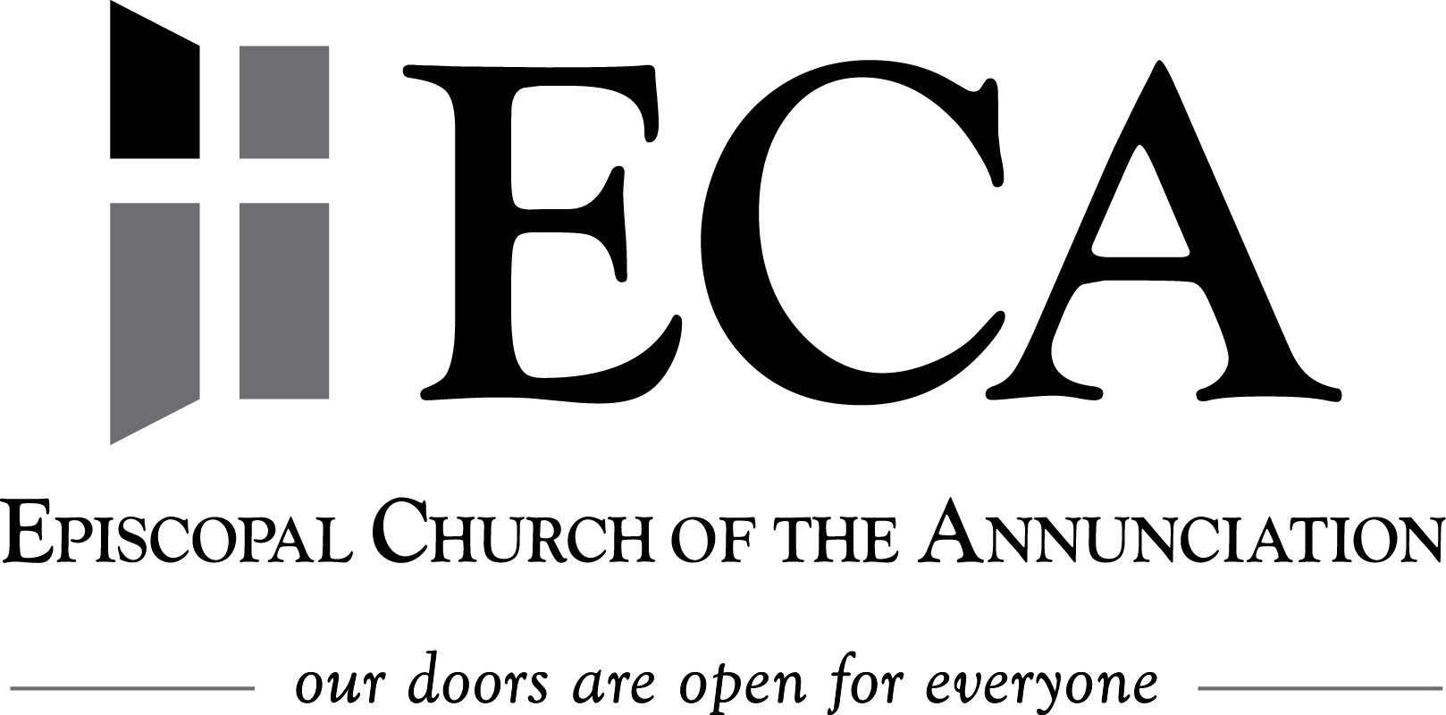

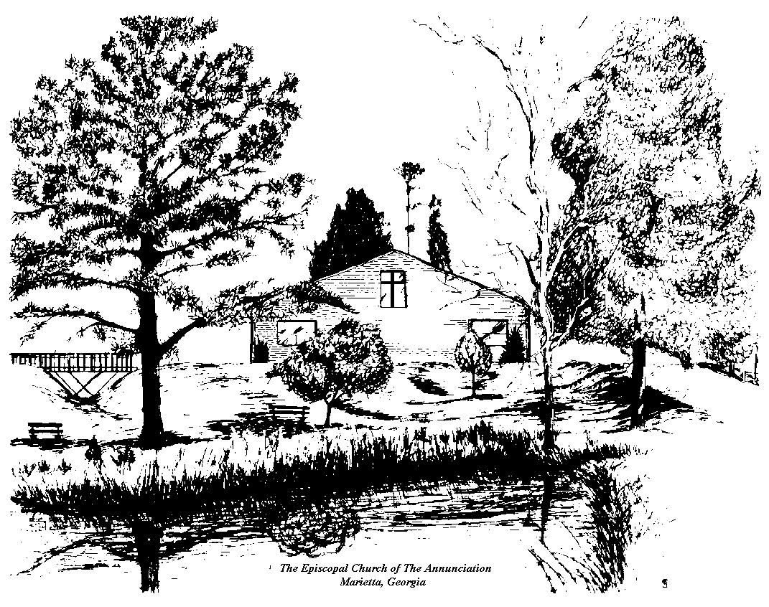

2016 Annual Parish Report

Almighty and everliving God, source of all wisdom and understanding, be present with those who take counsel at Episcopal Church of the Annunciation for the renewal and mission of your Church. Teach us in all things to seek first your honor and glory. Guide us to perceive what is right, and grant us both the courage to pursue it and the grace to accomplish it; through Jesus Christ our Lord. Amen

Everliving God, whose will it is that all should come to you through your Son Jesus Christ: Inspire our witness to him, that all may know the power of his forgiveness and the hope of his resurrection; who lives and reigns with you and the Holy Spirit, one God, now and for ever. Amen

www.ecamarietta.org  1673 Jamerson Rd. Marietta, GA 30066  (770) 928-7916

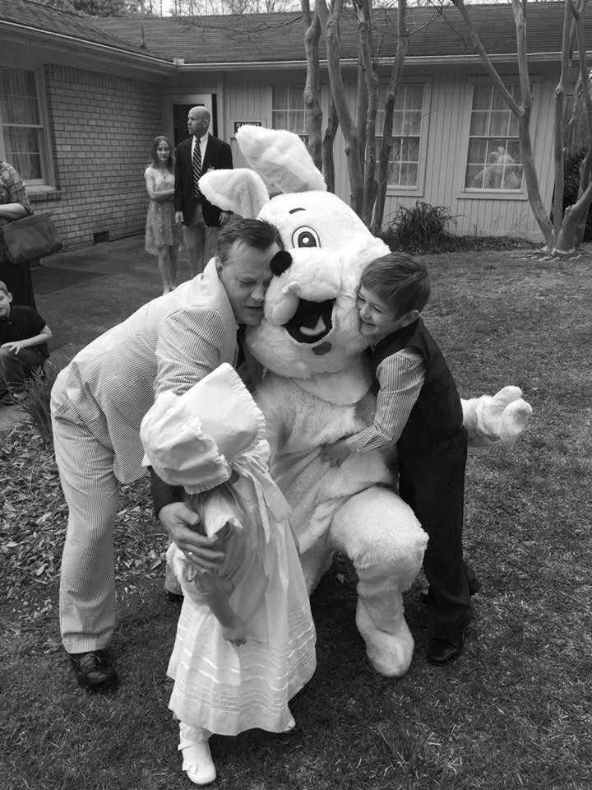
Our Reach ministry had another incredible year continuing its message of hope and faith by serving those in need in our communities. Reach started the Open Hearts ministry on campus and for the first time in the life of ECA mounted an international mission trip to the Dominican Republic with 11 members. It is not easy to quantify how many people’s lives we transform through our Reach ministry, but there is no doubt we are having an impact. We even had a parishioner start a national ministry in response to the floods in Baton Rouge, LA and through her work over 355 affected families to date have been given some sort of assistance. We had two more successful yard sales and because of the funds raised we will be able to help sponsor a trip to the National Cathedral for Emmaus House youth and ours at the acolyte festival being held there. It is obvious that ECA takes Christ’ message to heart when we are asked to “Therefore, Go, and make disciples of all nations.” We are the hands and feet of Christ when we serve one another and God’s children who are in need; “It’s what we do!”
We continue to work on maintaining our parish grounds but it is an ongoing challenge. We installed our sound system, finally got landline Internet and have all buildings WiFi capable. Our budget approved by the Vestry is challenging, but we have proven 2 years in a row now that we have been able to raise the funds necessary to accomplish the goals we set before us. I also want to take this opportunity to thank each and every member of the parish, Ministry leaders, the Vestry and my family for making my role as spiritual leader and rector an incredible job to have. A special thank you to our Sr. Warden Bliss Peterson for doing such an amazing job during my sabbatical and for our outgoing Vestry members who will be missed for their incredible work accomplished in their time on Vestry; Cal Beck, Pam Bell and Sandi Harden, thank you for all you have done to serve Christ and his church. I am honored to serve and be served as rector at Annunciation and look forward to our continued future together. In Christ, Fr. Paul+

Rector Report 2016

Fr. Paul McCabe

Grace to you and peace from God our Father and the Lord Jesus Christ! Happy New Year is something we wish each other every year in hopes that the blessings and grace we receive daily will continue in the midst of all the craziness and uncertainty all around us. The year 2016 has flown by and we have accomplished many incredible things in the life of Annunciation and our ministry and mission we are called to do in the world around us. I am grateful for the over 7 years I have been at ECA and for my sabbatical this summer which provided some well-needed rest. Looking back over the year at ECA we have done some unbelievable things once again. Our attendance numbers may have leveled off this year after continued growth yearly, but our stewardship campaign this past year in creased in numbers with less pledges and this says a lot about our faith and membership. Thankfully, we were able to hire a full time assistant priest, and Mother Gretchen has fit right into the parish ministry and mission and her presence among us is great benefit to ECA.
There is much to rejoice and be thankful for at ECA and I would like to spotlight this years’ accomplishments. The Church Development Committee (CDC) was formed in 2015. During the 2016 year a much greater emphasis was placed on creating and implementing ideas on which the Vestry and CDC had been focusing the last couple of years. The CDC held two presentations and dinners in March where over 70 out of our 130 families attended and talked about the future of our ministry together. Out of these gatherings came an overwhelming response about creating an additional worship service time on Saturday and the desire to hire an assistant priest to help with the many ministries at ECA. The Vestry gave approval in April to hire an assistant priest and Mother Gretchen was hired and began June 2016. After my sabbatical we were able to implement Saturday night and Wednesday noon Eucharist services as well as continuing our Wednesday night services. We are still working on the shape and style of worship on Saturday, but we celebrate the opportunity for alternate worship times and have enjoyed seeing some new and familiar faces. The CDC also created a Christmas flyer to place in nearby neighborhoods to advertise our worship opportunities during the Christmas season.
Finance Report for 2016
Bliss Peterson, Senior Warden

Stewardship Report for 2016
Bliss Peterson, Senior Warden

The 2016 Stewardship Committee accomplished many things this year as they executed a year-round stewardship program. A wine and cheese meeting was held where parishioners were encouraged to attend and share thoughts about stewardship at ECA. In May a time/talent pledge campaign was conducted giving ministry heads information on interest in their ministries. We’ve highlighted many smaller ministries leading to increased involvement. Unique pledge cards were mailed to parishioners’ homes with a cover letter for the first time and were met with great feedback.
The best feedback we received was in response to the personal testimonies we heard from Chris Renaud, Trinity Atkinson, and Jan Samuel. The spontaneous offerings of gratitude for ECA in both services that resulted from those testimonies were significantly meaningful and powerful to hear.
Our Pledge statistics for 2017 are: 97 pledges, totaling $221,915.00. Average pledge is $2288. 2016 ending stats were 102 pledges totaling $201,848.00, with an average pledge of $1978.90.

Budget 1

I have also spent the last six months listening to you and some of the ideas that you have for spiritual growth and ministry. So, in response I will be offering:
- A class for adults seeking confirmation. This class will begin on January 22 during the Sunday School hour.
- For Wednesday evenings, Fr. Paul and I will be working on a bible study as part of the Wednesday Evening Eucharist.
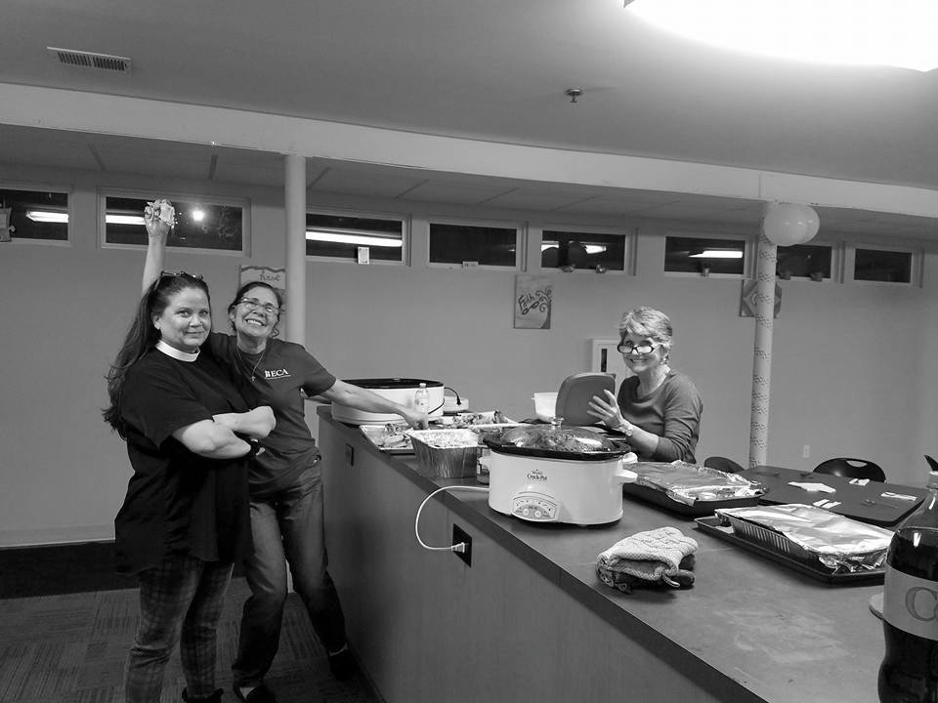
- Also, on Wednesdays, our “Let the Spirit Move You” class will move indoors and it, too, will have a bible study/spiritual study component. Instead of walking (it’s a bit cold, right now), we will have this study time together directly after the noon Eucharist and then that will be followed by some meditative time (i.e. yoga, prayer time, etc.)

Many thanks to each of you for welcoming me so fully into the arms of this faith community! I truly feel so blessed to be a part of the sacramental life, the ministries, and the fellowship of ECA. Just as Indiana Jones when confronted with the daunting task of choosing wisely, the holy grail of Christ, I am convinced that when answering God’s call to come to ECA I have chosen wisely. I looked to serving and growing with you as we continue this transformative journey that God’s calls each of us to take.
And may the grace of our Lord Jesus Christ, and the love of God, and the fellowship of the Holy Spirit, be with us all evermore.
With Christ’s love,
Mtr. Gretchen

Assistant Priest Report 2016

Mtr. Gretchen Ratterree

Dear ECA Family,
Where to begin? Coming to serve this wonderful faith community has been an answer to my prayers. Your warm and inviting reception of me has been a blessing! On the Sunday after my ordination, my parents said to me, “You have found a home with this community.” And I must say, I completely agree with them. Your faith in Jesus helps to strengthen mine every day. Your ability to pull together as a community and accomplish such amazing ministries, encourages me as well. As I look back on the six months that I have been with you I see the support you have provided in my own ministry with you.
- During the summer (and realizing that our annual visit from the Bishop would be in October) a Confirmation Class was offered to meet weekly. As a result, when the Bishop came, we had five youth who were confirmed.
- Placing teachers for Sunday School programs in most churches can be a difficult task. And yet, before the summer was out, we had filled all of our positions. In August, a teacher training day that included training for Safeguarding God’s Children was offered and attended by 20 people!
- In November, in response to the Men’s Fishing Weekend, the ladies of ECW had their own weekend get-away. We went to Jane Grey’s lake house and had a spectacular time.
- Our Daughters of the King chapter is a stage of reorganization and I am meeting and working with these wonderfully spirit-filled ladies at their monthly meetings. We will be offering a DOK luncheon on January 22 after the 10:30am service for all the women in the church. This will be an opportunity to invite others to join the ECA chapter.

Budget 2

Buildings & Grounds
Chris Crookless, Jr. Warden

2017 was a productive year for our Buildings & Grounds Ministry. The biggest thing we accomplished renovating the basement in the Swift Building. When the youth’s Christian Education classrooms flooded, we used it as an opportunity to install new, better flooring, base molding, repainted the walls and generally improved an area that needed improving. If you haven’t seen the differences made, you should! Our volunteers did a wonderful job.
We are planning to put up a new electronic sign to better advertise ECA to passersby. The application and required county documents are in process. A new roof on the Activities Building and new gutters on the Activities and Swift buildings were installed thanks to Daryl Sundberg and his team. So much more was done throughout the year both inside and out. Thanks to everyone who put time and effort into making our church home a better place to come together for worship.

Church Development in 2016
Doug Sweet

The Church Development Committee has accomplished so much this year. Most recently and for the first time, we advertised our upcoming Christmas services and activities to local neighborhoods through door hangers. We are in process of finalizing a permit to place a new electronic sign in front or ECA to better advertise our activities and maximize curb appeal. Research has been done to set up a bequeathment program for ECA. Research has also been done to seriously explore capital campaigns in other parishes, as that may be something that would benefit ECA in the future.

Parish Life in 2016
Rick Horner

Parish life comes in a variety of forms and we are always discerning ways to bring members of the parish together besides just Sundays. St. Martha’s Guild continues to plan, organize & implement a multitude of baptismal & funeral receptions with efficiency & great hospitality. Coffee Hour continues to function well and is our opportunity to show hospitality to one another and our guests who come to be with us on Sunday. The Lunch meets the first of the month after the second service and goes to various locations in and around Church of the Annunciation in our community.
The Tea Time Ladies held their 3rd Annual Tea in February to great success, and during the 4th quarter are in the middle of planning and execution for the 4th Tea. The ECW or Episcopal Church Women is a chance for women of the parish to come together and fellowship with one another. Under our chairperson, Jane Whisler, the ECW has had many fun events including painting classes, and a ladies weekend outing to a parishioner’s lake house. The ECA Men’s Group had another great fishing trip to Florida along with other get-togethers and minor work projects throughout the year.
There are many activities and events that are taking place during the year at ECA and it is important to assist in coordinating dates and the particulars of all that is taking place. We also continue seeking volunteers to help at events.

Reach in 2016
Katie Dunlap

Reach continues to support the Men's and Women's Extensions, with Desi Doucet coordinating the Women's Extension and Doug Sweet coordinating the Men’s Extension. We supported Emmaus House with a toy drive, a grandparents dinner and more. Reach provided lunch for Church of the Common Ground many times throughout 2016. A Fall Yard Sale and a Spring Yard Sale took place to raise money for Reach and made over $8,000.
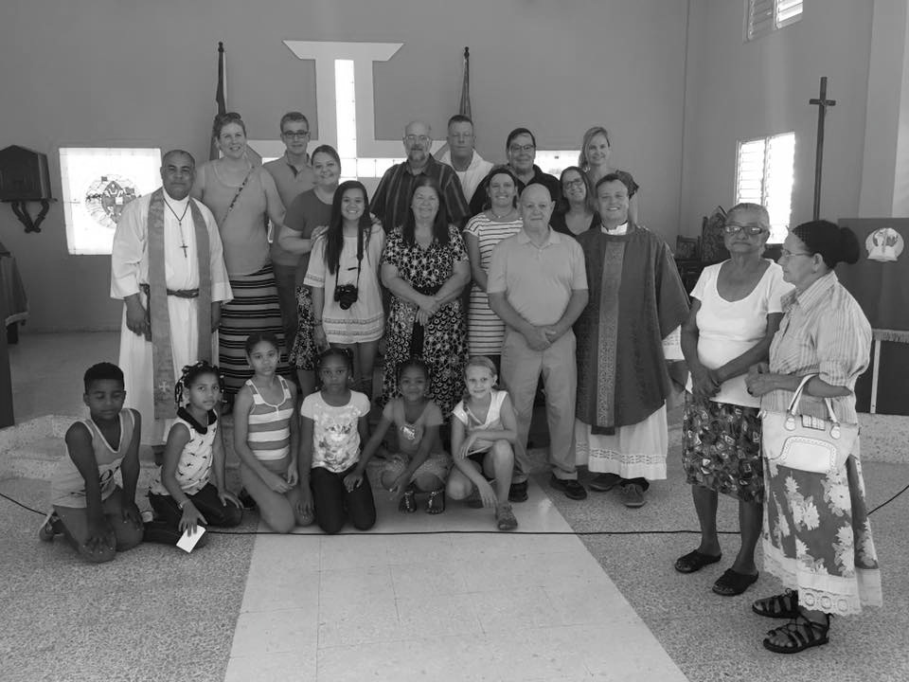
We had some firsts in 2016! Our first summer day camp, Open Hearts Project, was introduced as a one day a week camp for the homeless in our community. Our first mission trip to the Dominican Republic in July was a huge success. We supplied turkey dinners to 5 homeless families in our community for the first time. We also had our first giving tree to supply Christmas for a homeless family. We were introduced to Adopt a Flood Family in Baton Rouge and met many of the needs for those victims. Desi Doucet organized and delivered donations.

Faith & Spirituality Report in 2016
Sandi Harden

Our Christian Education goals for the year were to advertise and educate the parish more about class opportunities, recruit more teachers, increase attendance at the youth & adult classes, and make sure all those required by the Diocese to complete Safeguarding God’s Children/God’s People courses did so. We completed many goals, but have much room for improvement especially with Christian Education attendance. We conducted training for Safeguarding God’s Children. All Vestry members, staff and Christian Educators completed the required Safeguarding courses.
We have 11 Youth and 3 Adult instructors. Christian Education Instructor training and reference manuals were created. We introduced more intergenerational activities, i.e. all Hallow’s Eve Celebration and advent wreath making. However, Sunday attendance continues to decrease in both youth and adult classes.
The Christmas Pageant continues to be successful with very high attendance. The 4-week Lenten program was well attended. Children's Chapel continues on the 2nd Sunday of the month. Chapel now includes choral performances for special occasions such as the Bishop’s visit. This year we had five youth confirmed and one adult received.
We held our first annual parish retreat in September at Camp Mikell, which was attended by 43 parishioners. A post retreat survey showed a very high level of satisfaction. We look forward to repeating this successful event in the future!

Youth in 2016
Katie Dunlap

Rachel Cangemi kept the youth busy with fun activities throughout the year including pizza parties, bowling, lock-ins, and more. A mission trip to Louisiana in July allowed the youth to put some good out into the world in a fun and exciting way. There were many service opportunities and food drives and the youth were present at many Reach events including dinners at The Extension and wrapping presents for the youth at Emmaus House. The annual cheesecake fundraiser was a success as was the ever-popular Shrove Tuesday Pancake Dinner. Finally, Youth Sundays during the 10:30am service were held and enjoyed by many. We’re proud that so many youth are taking on more roles in the church like being a lector or being a part of a committee.

Servant Ministries in 2016
Pam Bell

All those involved in Servant Ministries should be proud of what they accomplished in 2016. Dedicated Visiting Eucharistic Ministers reached out to, visited and shared communion with members who were not able to attend church services. Family visits and other acts of family support were made when needed. Hospital visits were done mostly by our priests with a few follow up visits done by parishioners. Happy Cookers prepared meals and delivered them to parishioners who needed this support. Journeys continued to provide support for members going through loss. Jan Thurmond continued to send cards to parishioners who are celebrating events and for other events. On average each month 35-40 cards were sent. Volunteers faithfully provided transportation to and from church to members needing this support. Memorials were held for loved ones throughout the year. New procedures were put into place and guidelines provided to families when appropriate.
Worship in 2016
Ron Sedgley

Our worship committee has been making some noise this past year! Our much-requested Saturday service began September 24th and has been steadily growing ever since. Each service is followed by a different fellowship event that can range from sitting around the fire pit, or going out to eat at a local restaurant and seeing a show.
We also added a Wednesday Noon Service in September, and revamped our Wednesday Night Bible Study to focus on the Eucharist service already taking place.
Our Holy Week and Christmas Services were a huge success thanks to our many volunteers. We had 330+ at the Easter services and 47 children participate in the Christmas pageant this year – unbelievable numbers. Many thanks also to Fr. Bruce Laird who conducted services while Fr. Paul was away on sabbatical. We also welcomed Mtr. Gretchen Ratterree as our new Assistant Priest. We gave been enjoying her presiding over service since min-June. Our choir has continued to grow and thrive under our Music Director, Joe Lozier.
